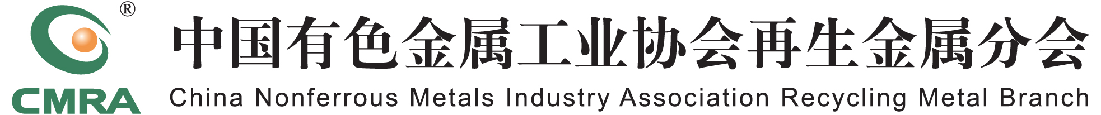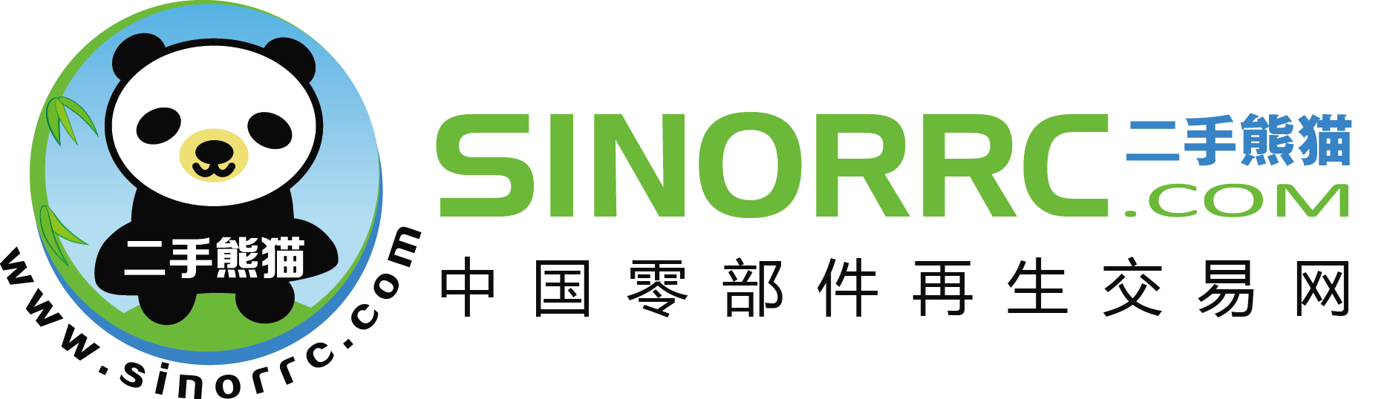
国际再生金属展览交易会供需信息发布表
The International Recycling Metal Exhibition & Trade Fair Supply/Demand Form
品种  Metal | □铜Cu □铝Al □铅Pb □锌Zn  □锡Tin □镍Ni □稀贵Scarce And Precious | 类型  Type | □求购方Purchase Side □供应方 SALE Side
企业名称Company Name |  | 主营业务  Main Business | □拆解Dismantling □加工Processing □贸易Trade  □设备Equipment □媒体Media □其他Others
联 系 人Contact Person |  | 联系电话  Tel and MP
联系地址Address |  | 邮箱  E-mail
□ 长期求购 □ 长期供应 □ 同步到中再交易网
供需信息
Supply/Demand Info.
备注：1. 组委会不对此供需信息的真实性负责！请洽谈双方注意风险，自行斟酌洽谈！
2. 请将此表Email至中再交易网：zhy@crra010.com，以便组委会提前打印张贴在展馆相应区域。
Remark: 1. The Organizing Committee is not responsible for the authenticity of the supply/demand information! Please be aware of the risk when negotiating.
2. Please email tozhy@crra010.com, it will be print out and label on supply & demand information board.

